Triage bands

Triage bands are colour coded ‘slap-bands’ that are carried within the lifeboat kits to be used in conjunction with the Triage card within the Casualty Care check cards as shown.

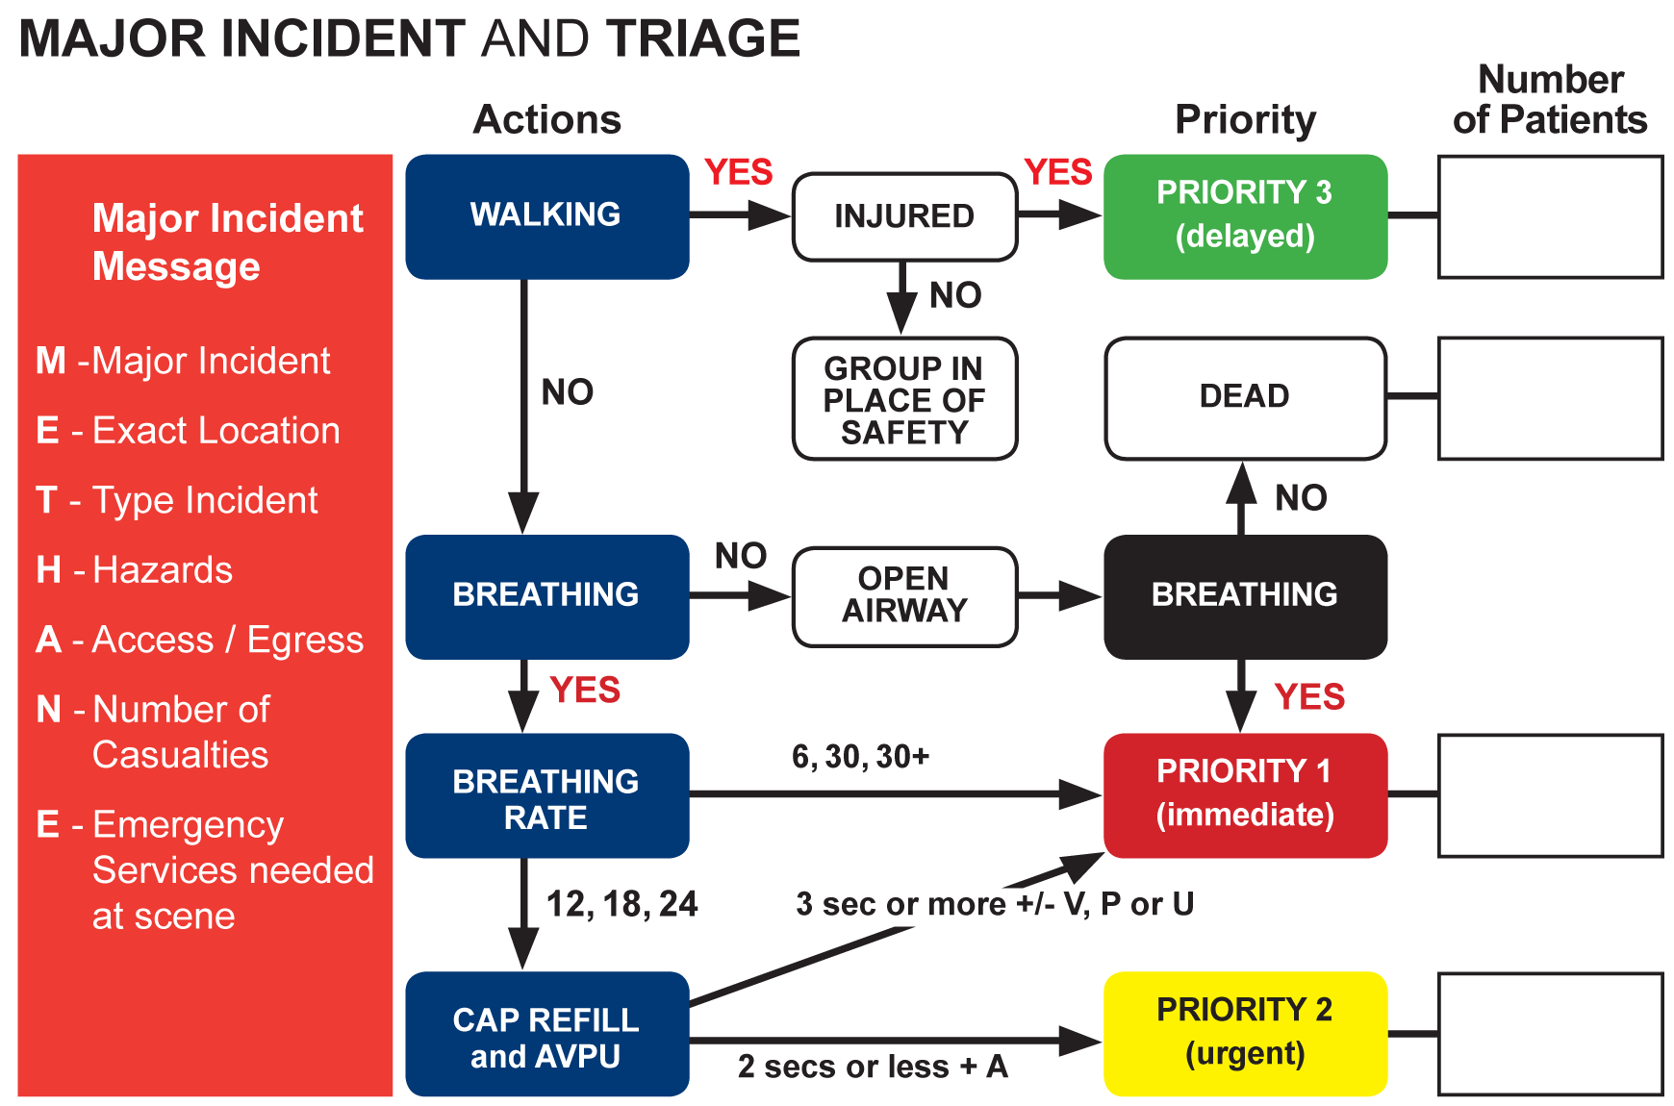

Triage comes from the French word ‘to sort’ and is put into effect when an incident with more casualties than rescuers presents. Both lifeboat crew and lifeguards use the card and system, (lifeguards label patients by writing the priority code on the patient’s forehead clearly with a chinagraph).

The triage system is a process which starts sorting and finding out where the priority patients are and relaying vital messages back to a control point so the necessary resources are sent. Its overall aim is to ensure that as many people are saved as possible. The ‘dead’ label has to be used when patients are not breathing despite an open airway. Casualty carers move on from patients who are not breathing with an open airway to treat Priority 1 patients and others as this is to ensure best chance of survival for the most patients possible.

Once a message has been passed back with the number of casualties and their priorities, re-triaging can occur in order to keep a check on priorities.

The METHANE message in red on the left hand side of the card is only to be used if the emergency services ask you for a METHANE message in relation to a Major Incident.

